THE UNIVERSITY OF THE SOUTH PACIFIC

CS219: CLOUD COMPUTING

ASSIGNMENT 1 2026


NAME : William Selui
ID : s11244878
Table of Content

PART A
Question 1

- Definition of Cloud Computing
Cloud computing is the delivery of computing resources such as servers, storage, and software over the internet, rather than a business owning and running its own physical hardware [1]. Instead of buying servers to host her marketplace, Mere could rent computing power and storage from a provider and pay only for what she uses.
The main characteristics of cloud computing are on-demand self-service, where a consumer can provision resources without contacting the provider directly; broad network access, meaning the service can be reached from any internet-connected device; resource pooling, where many customers share the same underlying infrastructure; rapid elasticity, which allows resources to scale up or down as demand changes, such as during a promotional sale; and measured service, where usage is tracked and billed on a pay-as-you-go basis [1], [2]. Cloud environments are also expected to show resiliency, meaning redundant resources are distributed across different physical locations so a service can keep running even if one component fails [2]. This last point matters for Mere specifically, given how exposed the Pacific is to cyclones and power outages (see part iv).

- Advantages of Cloud Computing for Mere’s Marketplace
Cloud computing would let Mere avoid the high upfront cost of buying and maintaining her own servers, since she can rent infrastructure instead and move spending from capital expenditure to operating expenditure [2]. It also gives her scalability: as her marketplace grows and more customers or businesses join, she can increase storage and processing capacity without buying new equipment [1]. Cloud-based SaaS tools reduce the technical burden on her, since she would not need her own dedicated IT team to manage servers or handle software updates. Her platform would also be accessible to customers and business owners from anywhere with internet access, which suits a business trying to reach different islands. Finally, established cloud providers generally offer strong uptime and backup systems, giving Mere more reliability than she could realistically set up on her own with limited resources.

- Disadvantages and Limitations
Subscription costs for cloud and SaaS services can add up over time and may become expensive as the business grows. Because everything runs through the internet, the business becomes fully dependent on a stable connection, so any outage could stop operations completely. There are also concerns around the confidentiality and integrity of data, since customer information and payment details would be stored and processed by a third party rather than Mere herself, which raises trust and security issues [4]. Vendor lock-in is another limitation: switching cloud providers later could be difficult or costly once the business becomes dependent on one platform's proprietary tools [3]. Finally, SaaS solutions may not always be fully customizable to fit Mere's specific business processes compared with a custom-built system.

- Considerations in the Pacific Island Context
Several factors could affect whether Mere's cloud-based business is realistically feasible in Fiji and other Pacific Island countries. Internet connectivity is one of the biggest concerns, since many rural or outer-island areas still experience slow or unreliable internet, which would directly affect access to her platform. The cost of data and internet services in the Pacific is also relatively high compared with income levels, which could raise her operating costs and make the platform less affordable for some customers [5]. Digital infrastructure is another issue, since there are no local cloud data centres in Fiji, meaning most cloud providers host data overseas, typically in Australia or Singapore, which introduces latency [5]. Cybersecurity is also a concern, as the region has comparatively lower awareness and regulation around online security, so Mere would need to rely heavily on the security measures of her chosen provider [4]. There is also a shortage of local technical expertise, which could make cloud-related issues harder to manage or troubleshoot [5]. Lastly, natural disasters such as cyclones and general power reliability issues in the Pacific could disrupt access to the platform even if the cloud provider itself remains stable; this is where the resiliency characteristic discussed in part (i) becomes relevant, since redundant, geographically distributed infrastructure can reduce, though not eliminate, this risk [2].
Overall, cloud computing could still work for Mere's business, but its success would depend heavily on stable internet access, cost management, and how well she plans around the region's infrastructure limitations.

Question 2

- Software as a Service (SaaS) Model
Software as a Service (SaaS) is a cloud computing model where applications are hosted by a service provider and accessed by users over the internet, usually through a web browser [1]. The provider manages the underlying servers, storage, operating systems, software maintenance, and updates, while the customer mainly uses and configures the application [6].
For Mere's online marketplace, SaaS could let her use ready-made online services for functions such as inventory management, accounting, customer communication, and order management. Instead of purchasing servers and installing and maintaining software herself, she could subscribe to these services and access them online, reducing the amount of technical infrastructure she needs to manage. This differs from traditional software, where applications are normally installed and managed on the business's own computers or servers, with the business responsible for installation, hardware, updates, and security patches. With SaaS, these responsibilities are largely handled by the provider, which can reduce upfront costs and make software easier to deploy [6].

- Proposed Online Business
Mere could operate her online marketplace using SaaS applications accessed through the internet, letting the business use cloud-hosted software without managing the underlying servers and infrastructure [1]. For customers, the marketplace could provide product browsing, online ordering, electronic payments, order confirmations, and delivery or purchase updates. For participating local businesses, the platform could provide tools to upload products, update prices and stock levels, receive and manage customer orders, track sales, and communicate with customers.
These SaaS services would work together by sharing information across the marketplace. For example, when a customer places an order, the order-management service could notify the seller, update inventory records, process payment information, and send the customer an order update. Because the applications are cloud-based, Mere and participating businesses could access these services online without maintaining the underlying cloud infrastructure themselves [1].

- Cloud Architecture
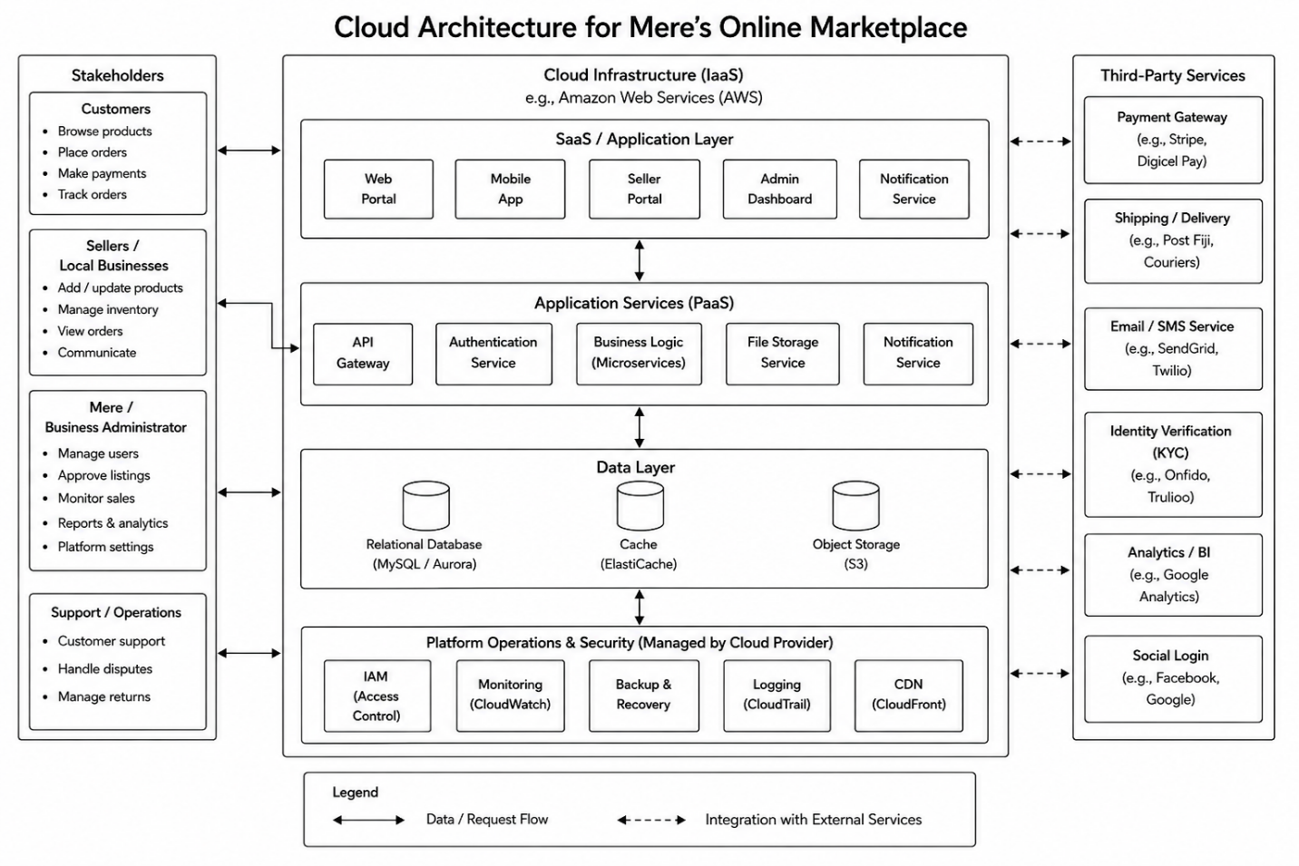

Cloud Architecture Explanation
The diagram shows how Mere’s online marketplace can operate using cloud computing and SaaS services. Customers can access the marketplace through a web or mobile application to browse products, place orders, make payments, and receive updates. Local businesses can use the seller portal to manage their products, inventory, and customer orders, while Mere can manage the overall platform through the admin dashboard.
The cloud infrastructure handles the main services of the marketplace, including user authentication, order processing, notifications, file storage, and database management. Important information such as customer details, products, inventory, and orders is stored securely in the cloud.
The platform also connects with third-party services for online payments, delivery, email/SMS notifications, identity verification, analytics, and social login. Overall, this architecture reduces the need for Mere to maintain physical servers and allows the marketplace to scale as more customers and local businesses join the platform.

- Advantages, Disadvantages and Future Considerations
The SaaS model offers Mere several concrete benefits over building and hosting her own infrastructure:
- Low upfront capital investment — Mere avoids the cost of purchasing servers, networking equipment, and software licences, instead paying a predictable subscription or usage-based fee [3].
- Rapid deployment — SaaS platforms, such as Shopify or WooCommerce on a cloud host, or a custom application built on AWS or Google Cloud, allow Mere to launch her marketplace in weeks rather than months, since infrastructure, security patching, and platform maintenance are handled by the provider [7].
- Scalability and elasticity — as more customers and vendors join, Mere can scale computing and storage resources up or down automatically without re-architecting her system, a core cloud characteristic known as rapid elasticity [2].
- Accessibility — because SaaS applications are delivered over the internet, customers and business owners across different islands can access the marketplace from any device with a browser, without needing specialised local hardware.
- Reduced IT burden — the SaaS provider manages server maintenance, security patches, and backups, so Mere does not need an in-house IT team, which matters given the shortage of specialised ICT skills in many Pacific Island economies [5].
- Built-in disaster recovery — reputable providers replicate data across multiple data centres, reducing the risk of total data loss from local hazards such as cyclones, a genuine concern in the Pacific region.
However, the model carries real limitations, several of which are amplified by the Pacific context:
- Dependence on internet connectivity — SaaS is unusable without a stable connection. Fiji and other Pacific nations rely on a small number of undersea fibre-optic cables, such as the Southern Cross Cable, and damage to these can disrupt national internet access for extended periods [5]. This is a significant operational risk for an online-only marketplace.
- Data residency and latency — most major cloud providers have no data centres physically located in the Pacific Islands; the nearest are typically in Australia, New Zealand, or Singapore. This introduces latency and raises questions about which country's laws govern Mere's customer data [2].
- Data security and privacy concerns — storing customer payment details and personal information with a third-party provider means Mere is trusting that provider's security practices, and Fiji currently has limited comprehensive data-protection legislation, leaving ambiguity around liability if a breach occurs [4].
- Vendor lock-in — once Mere builds her marketplace on a specific SaaS platform or cloud provider's proprietary tools, migrating to another provider later can be costly and technically difficult [7].
- Ongoing subscription costs — while upfront costs are low, recurring subscription and transaction fees can accumulate and, at scale, may exceed the cost of owned infrastructure.
- Limited customisation — off-the-shelf SaaS platforms may not perfectly fit Mere's specific business processes, forcing her to adapt her workflow to the software rather than the reverse.
As the business matures, Mere should also plan for:
- Business growth and scalability — choosing a provider and pricing plan that supports elastic scaling, such as pay-as-you-go compute and storage, so the platform can handle seasonal demand spikes, for example before Christmas or during local festivals, without manual intervention [2].
- Data security — future investment in encryption at rest and in transit, multi-factor authentication for vendor and admin accounts, and regular security audits as the platform handles increasing volumes of payment data [4].
- Integration with other services — connecting the marketplace to accounting software such as Xero or QuickBooks, logistics and courier tracking systems, and social media platforms such as Facebook and Instagram, where many Pacific small businesses already market their products.
- Mobile applications — given high mobile penetration relative to fixed broadband in Fiji, a dedicated mobile app or a mobile-optimised progressive web app would likely reach more customers than a desktop-first site.
- Additional payment options — beyond card payments, integrating Pacific-relevant mobile money services such as Vodafone's M-PAiSA and Digicel's MyCash, which are widely used for everyday transactions in Fiji and reach customers without bank accounts.
- Expansion to other Pacific Island markets — scaling to Tonga, Samoa, or Vanuatu would require multi-currency support, potentially multi-language support, and awareness of each country's import and export regulations and local payment infrastructure.
- Hybrid or multi-cloud strategies — to reduce the risk posed by undersea cable outages and single-provider dependency, Mere could eventually cache critical services locally or use multiple providers for redundancy [5].

PART B
Question 3
USER GUIDE
This guide explains how the lab was configured using Oracle VirtualBox. Two virtual machines were created: SRVMA1 using Windows Server 2012 and CLVMA1 using Windows 10. SRVMA1 was configured as a domain controller, DNS server, file server, and VPN server. CLVMA1 was configured as the client computer and joined to the domain.

Lab Configuration
Item | Configuration
Server VM | SRVMA1
Server computer name | S11244878SRVMA1
Server OS | Windows Server 2012
Client VM | CLVMA1
Client OS | Windows 10
Domain | S11244878.local
Internal LAN | Host-only Adapter/ Internal Network
External WAN | Bridged Adapter
Server LAN IP | 10.0.0.10
Client LAN IP | 10.0.0.20
Subnet Mask | 255.0.0.0
VPN IP pool | 10.0.0.100 – 100.0.0.110
VPN client IP | 10.0.0.101
Shared Folder | CLOUD

The Internal network was used for secure LAN communication between SRVMA1 and CLVMA1. The Bridged adapter was used as the external/ untrusted network for internet and VPN testing.

Task 1: Create SRVMA1
In Oracle VirtualBox, a new VM named SRVMA1 was created using the Windows Server 2012 ISO. The VM was assigned at least 1024 MB RAM and a virtual hard disk of 100 GB or higher. Two network adapters were configured:
Adapter | Type | Purpose
Adapter 1 | Host-only Adapter / Internal Network | Secure LAN
Adapter 2 | Bridged Adapter | External / WAN

Screenshot Evidence: SRVMA1 VB settings showing VM name, OS, RAM, storage and network adapters

Task 2: Configure SRVMA1
After installing Windows Server 2012, the internal adapter was configured with a static Class A IPv4 address:
Setting | Value
IP address | 10.0.0.10
Subnet mask | 255.0.0.0
Default gateway | Blank
DNS server | 10.0.0.10

The Bridged/ WAN adapter was left on DHCP so it could automatically receive an IP address from the internet network
The computer name was changed to S11244878SRVMA1
The Administrator password was set as required to P@$$w0rd12345

Verification commands:
- ipconfig /all
- hostname

Screenshot evidence: SRVMA1 IP configuration and computer name

Task 3: Configure Domain and Users
Active Directory Domain Services was installed on SRVMA1 using Server Manager. After installation, SRVMA1 was promoted to a domain controller by creating a new forest
S11244878.local
DNS Server was also installed during the domain controller setup.

After the server restarted, Active Directory Users and Computers was used to create two domain user accounts using the required naming conventions
firstname.surname

Screenshot evidence: domain created in Active Directory Users and Computers and both user accounts visible

Task 4: Create CLVMA1 and Join Domain
A second VM named CLVMA1 was created using Windows 10. It was assigned at least 1024 MB RAM and 80 GB or higher storage. The network adapters were configured as:
Adapter | Type | Purpose
Adapter 1 | Host-only Adapter / Internal Network | Secure LAN
Adapter 2 | Bridged Adapter | External / WAN

The CLVMA1 internal adapter was configured with
Setting | Value
IP address | 10.0.0.20
Subnet mask | 255.0.0.0
Default gateway | Blank
DNS server | 10.0.0.10

Connectivity and DNS were tested from CLVMA1:
- ping 10.0.0.10
- nslookup S11244878.local
CLVMA1 was then joined to the domain
S11244878.local

Domain administrator credentials were used to complete the domain join. After restarting, the client was able to log in using a domain user account

Screenshot evidence: CLVMA1 IP settings, ping/DNS test and successful domain membership

Task 5: Create CLOUD shared Folder

On SRVMA1, a folder named CLOUD was created C:\CLOUD

The folder was shared as \\10.0.10\CLOUD

Permissions were configured as follows
Account | Permission
Main user account | Full Control
Partner account | Read Access

The main user was able to create files in the CLOUD folder, while the partner was only able to read the contents.

Screenshot evidence: CLOUD folder, sharing permissions, security permissions, successful access and permissions-denied test for read-only user

Task 6: Configure VPN
The Remote Access role was installed on SRVMA1 with
- DirectAccess and VPN(RAS)
- Routing
Routing and Remote Access was configured using Custom Configuration with
- VPN access
- LAN routing
A static VPN address pool was configured
Start IP | End IP
10.0.0.100 | 10.0.0.110

The domain user account was allowed VPN access from the Dial-in tab in Active Directory Users and Computers

Before connecting, CLVMA1's internal adapter was disconnected/disabled for testing so that it had to connect from the external Bridged network. The VPN connection on CLVMA1 used SRVMA1's Bridged/WAN IP as the server address.

VPN settings
Setting | Value
VPN provider | Windows built-in
VPN type | PPTP
Server address | SRVMA1 Bridged/ WAN IP
Username | S11244878\firstname.surname

After connecting, CLVMA1 received a VPN IP address: 10.0.0.101
The CLOUD share was then accessed through the VPN: \\10.0.0.10\CLOUD

Screenshot evidence: RRAS enabled, VPN IP pool, user Dial-in permission, VPN connected, CLVMA1 VPN IP address and CLOUD folder accessed through VPN

Troubleshooting
During testing, the Bridged adapter initially failed on the campus network because only one bridged VM could receive a DHCP address. This suggested a network restriction such as MAC filtering or DHCP lease limits. To solve this, the computer was connected to a personal hotspot and the Bridged adapters were pointed to the active Wi-Fi adapter.
The internal Host-only network also had connectivity issues on one computer. The VMs had correct IP addresses but could not reach each other. ARP testing showed that the client could not detect the server. Internal Network was used as a working private LAN replacement so that the two VMs could communicate and the lab could continue.

The VPN initially failed because the VPN port was not reachable. This was tested using Test-NetConnection <SRVMA1_WAN_IP> -Port 1723, after restarting the RemoteAccess service on SRVMA1, the test succeeded and the VPN connected.

FINAL RESULT
The lab was completed successfully. SRVMA1 was configured as a domain controller, DNS server, file server, and VPN server. CLVMA1 was joined to the domain and accessed the CLOUD share. The VPN connection assigned CLVMA1 the IP address 10.0.0.101, and CLVMA1 successfully accessed:
\\10.0.0.10\CLOUD which confirmed secure VPN access from the untrusted external network to the internal file service.

